Lesson 21

**Relational databases. SQL query language. SELECT operator**

Level 1

**Create a database (with an arbitrary name)**

***CREATE DATABASE Homework***

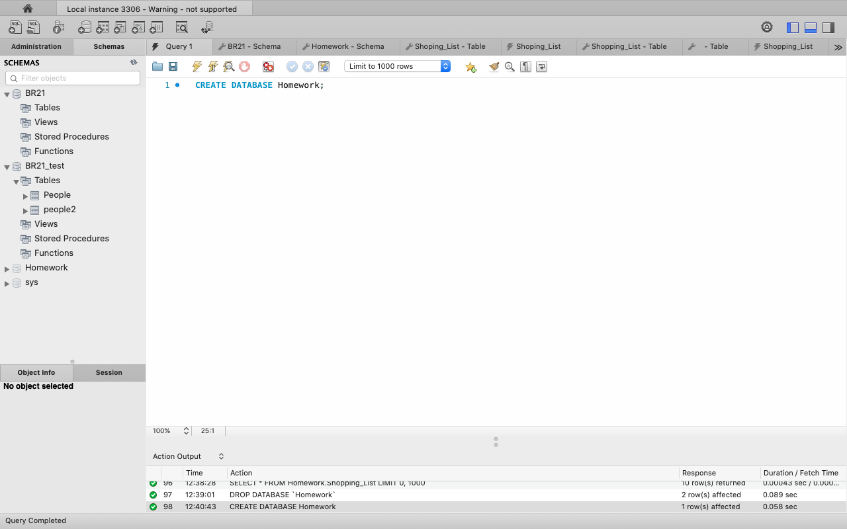

* **In this database, create a table called Shopping_List that contains fields named ID, Product_Name, Price, and Quantity.**
* **Determine which field will be the primary key.**

***CREATE TABLE Shopping_List***

***(ID INT AUTO_INCREMENT PRIMARY KEY,***

***Product_Name VARCHAR(255) NOT NULL,***

***Price DECIMAL(10, 2) NOT NULL,***

***Quantity INT NOT NULL)***

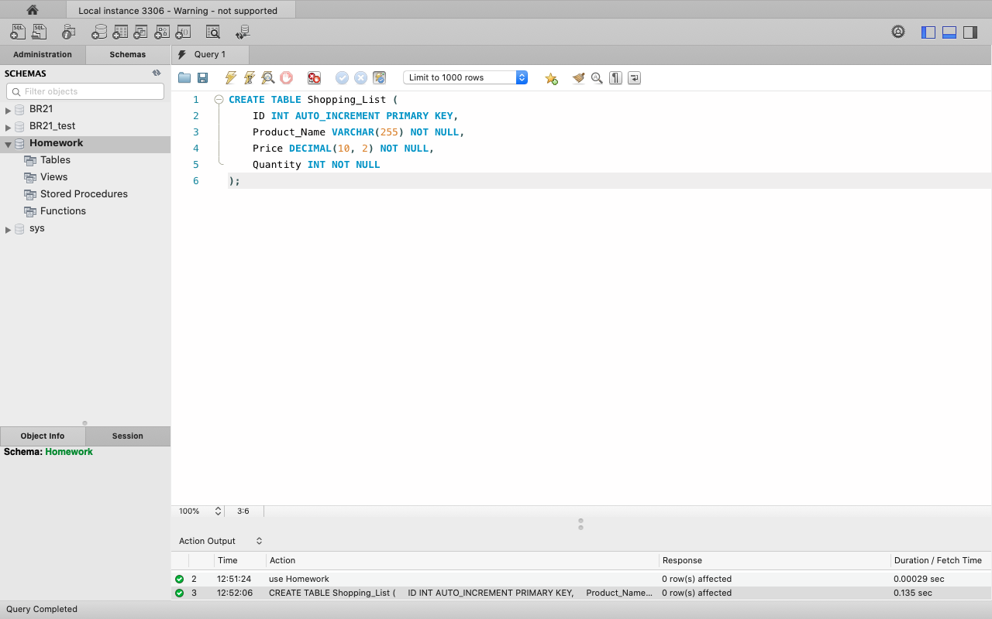

* **Enter 10 product names into the table and fill the Price and Quantity fields with arbitrary numbers.**

***INSERT INTO Shopping_List (Product_Name, Price, Quantity) VALUES***

***('broccoli', 10.99, 5),***

***('carrots', 5.99, 3),***

***('apples', 2.49, 10),***

***('lemon', 8.99, 7),***

***('cherries', 12.50, 2),***

***('spinach', 4.75, 6),***

***('pears', 6.25, 8),***

***('beefsteak', 15.00, 4),***

***('tomatoes', 9.99, 2),***

***('green_beans', 7.50, 3);***

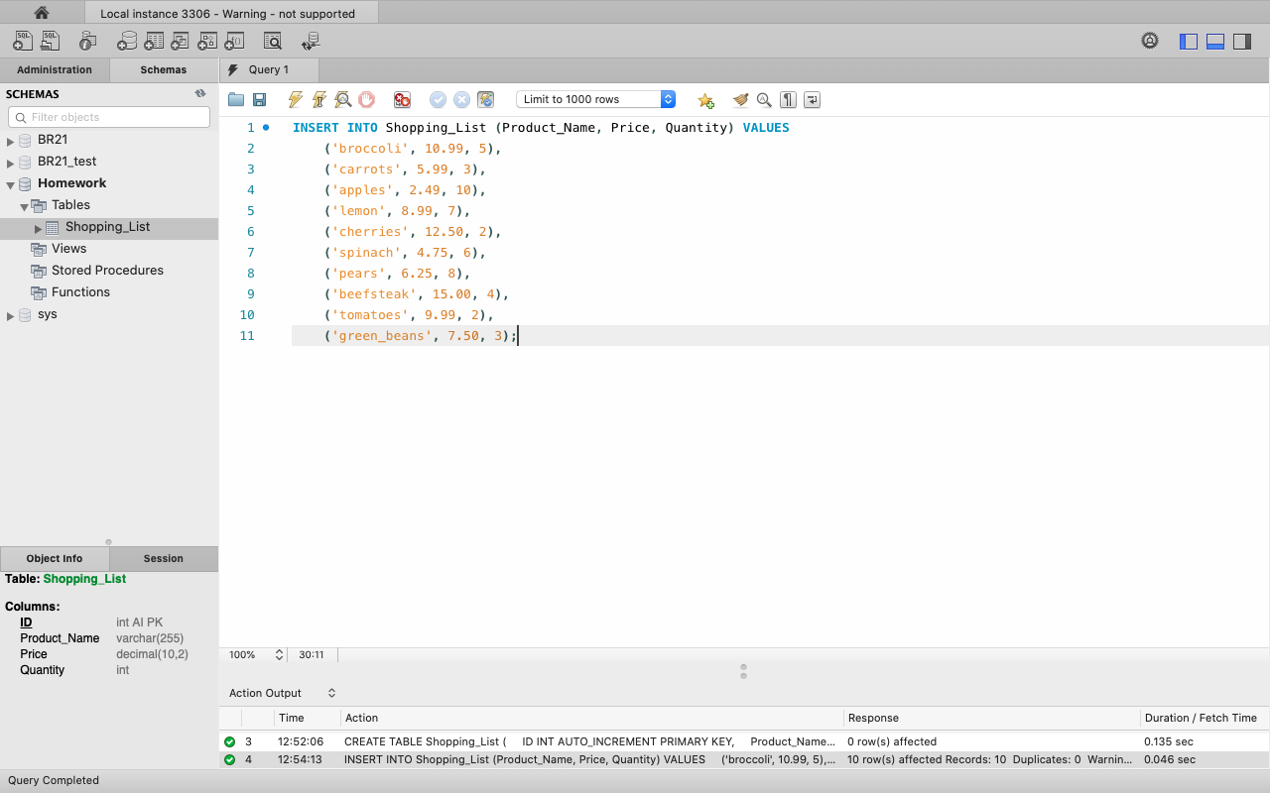

* **Create a request that displays all the fields of the created table.**

***SELECT * FROM HOMEWORK.SHOPPING_LIST***

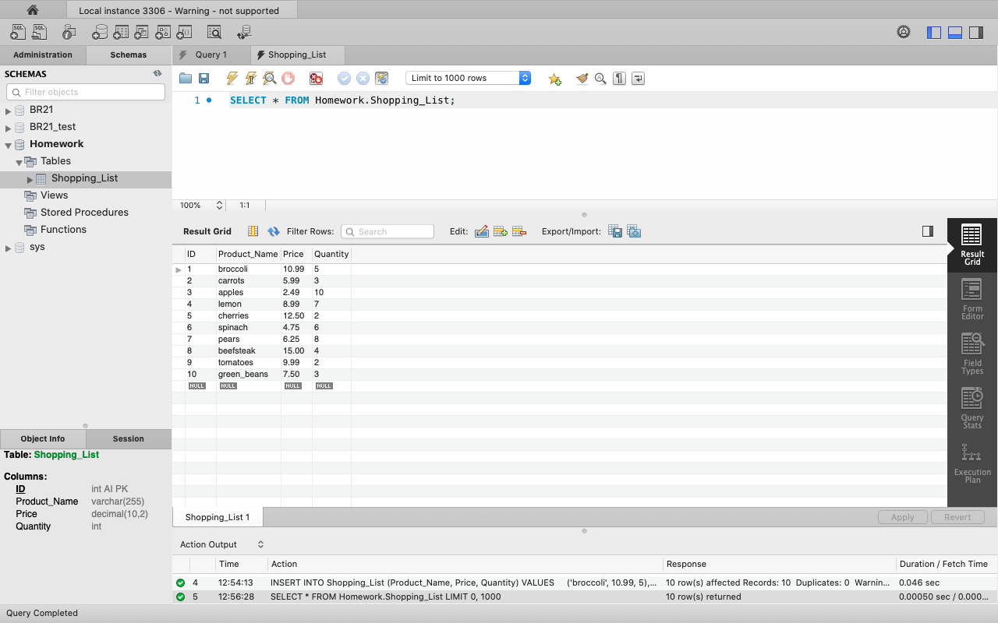

Level 2

**In an already created database, create a table of products named Fridge with fields:**

* **Item_ID, Product_ID, Product_Name, Quantity, Expiration_Date.**

***CREATE TABLE Fridge (***

***Item_ID INT AUTO_INCREMENT PRIMARY KEY,***

***Product_ID INT,***

***Product_Name VARCHAR(255) NOT NULL,***

***Quantity INT NOT NULL,***

***Expiration_Date DATE***

***)***

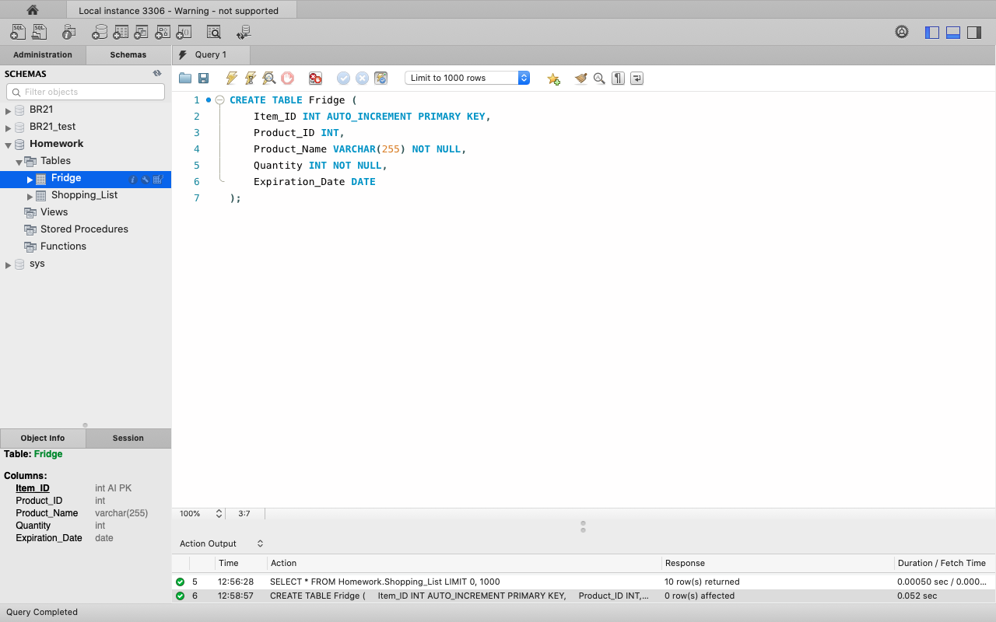

* **Add 10 products to the Fridge table, 5 of which will match 5 products from the Shopping_List table.**
* **Complete the table fields with the data of your choice.**

***INSERT INTO Fridge (Product_ID, Product_Name, Quantity, Expiration_Date) VALUES***

***(1, 'lemon', 7, '2023-11-15'),***

***(2, 'butter', 2, '2023-11-20'),***

***(3, 'tomatoes', 2, '2023-11-10'),***

***(4, 'potatoes', 4, '2023-12-01'),***

***(5, 'spinach', 6, '2023-11-25'),***

***(6, 'avocado', 6, '2023-11-18'),***

***(7, 'pears', 8, '2023-11-14'),***

***(8, 'carrots', 3, '2023-11-30'),***

***(9, 'green_beans', 5, '2023-11-29'),***

***(10, 'orange_juice', 2, '2023-11-12');***

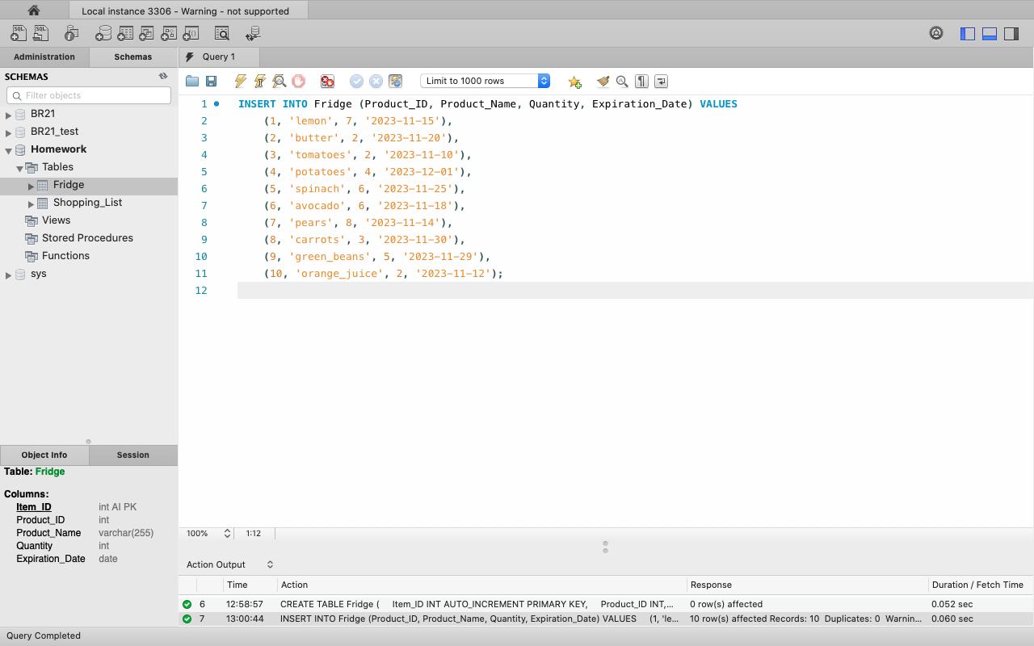

* **Link this table to the Shopping_List table using a foreign key.**

***ALTER TABLE Fridge ADD COLUMN Shopping_List_ID INT;***

***ALTER TABLE Fridge ADD CONSTRAINT fk_shopping_list***

***Foreign key (Shopping_List_ID)***

***REFERENCES Shopping_List_(ID);***

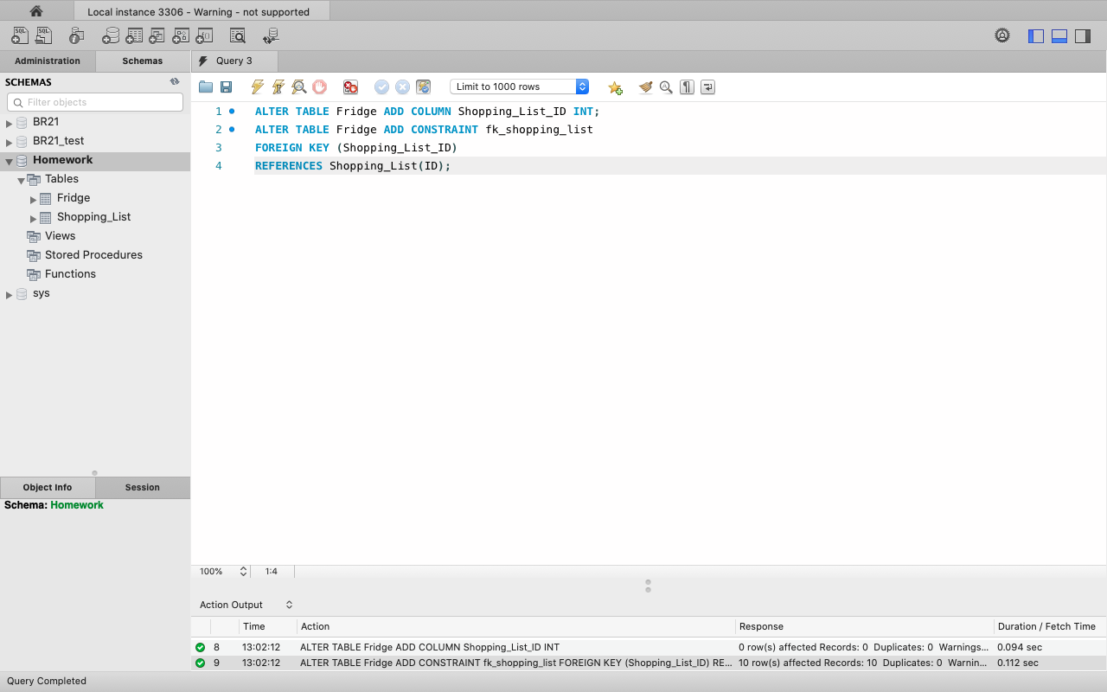

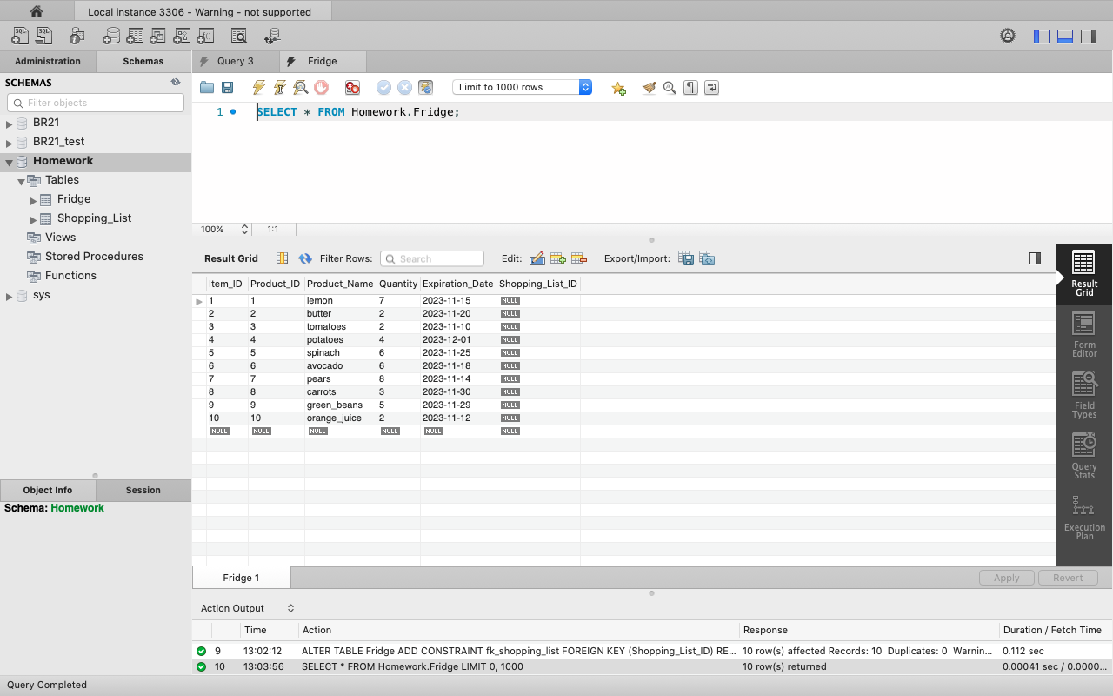

* **Draw an entity relationship diagram* of the created database, indicating the types of fields, primary keys, and relationships between tables.**

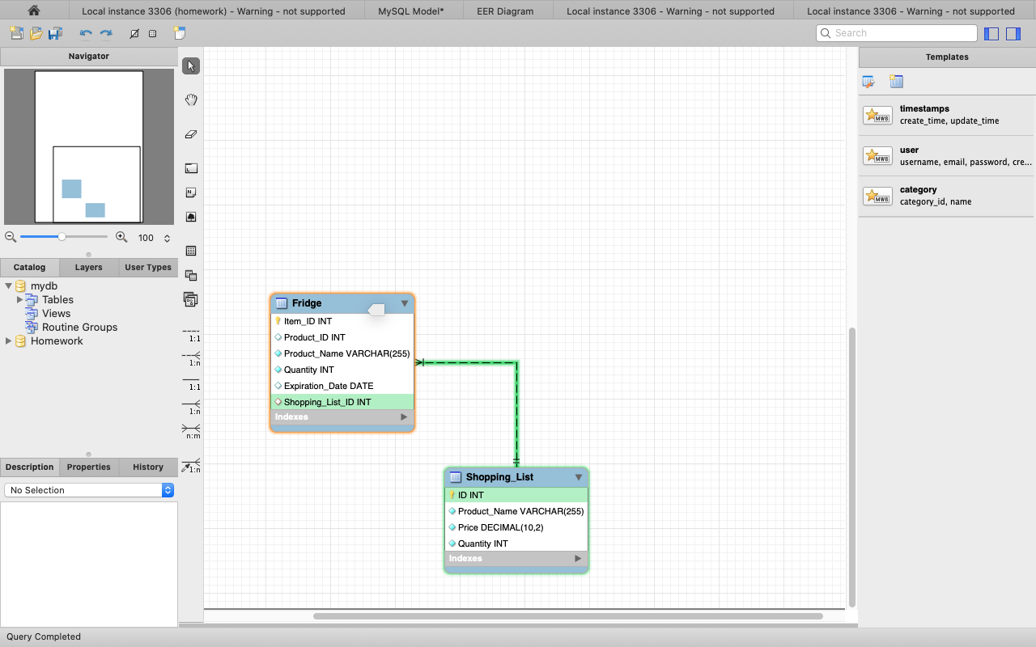

Level 3

**Add 10 products to the Fridge table, 5 of which are in the Shopping_List (not the total number of products that matter, but the related tables).**

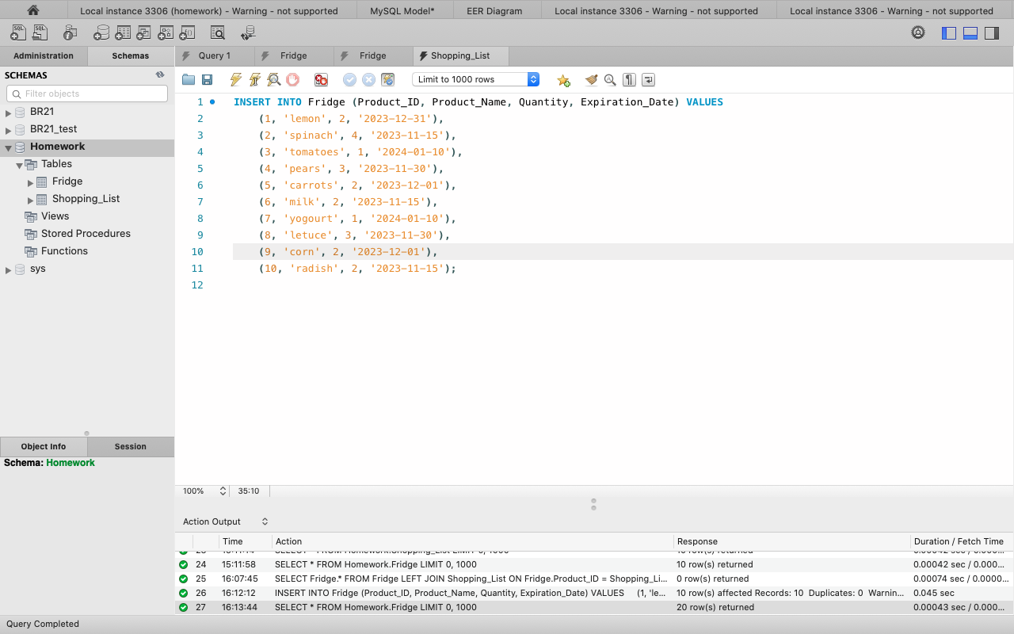

**Create a request displaying the products not in the Shopping_List table.**

***SELECT F.Product_Name***

***FROM Fridge F***

***LEFT JOIN Shopping_List S ON F.Product_Name = S.Product_Name***

***WHERE S.Product_Name IS NULL;***

